**Digital Accessibility**

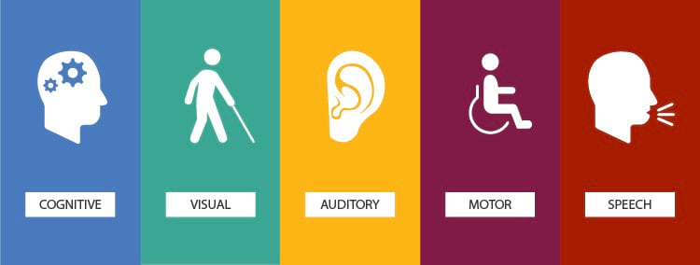

**Digital accessibility** means building digital platforms, content and applications that can be easily accessed and used by a wide range of people, including individuals who have visual, motor, auditory, speech, or cognitive disabilities.

As designers, we have the power and responsibility to make sure that everyone has access to what we create regardless of their ability, context, or situation.

Is accessible design **only for those with limitations**?

**No**, the great thing about making our work accessible is that it creates a **better experience for everyone.**

Generally, the process to create a website accessible is considered difficult and expensive, but it doesn't have to be if we always **design for accessibility from the very beginning.** Designing a product from scratch to meet the requirements for accessibility doesn’t add extra features or content; therefore there shouldn’t be additional cost and effort.

“Web accessibility means that people **with disabilities** can use the Web”

vs

“Web accessibility means that **everyone** can use the Web”

**Watch the video: An accessible process for inclusive design (Google I/O '18)**

**https://www.youtube.com/watch?v=TAzkrXTGEOM**

Let's learn about a process any team can use to design more inclusively for people with accessibility needs and how Material Design guidelines, tools, and components can help.

We need to change our focus from the “people with disabilities” to inclusivity. There is a note on ableism, the belief that able-bodied people are the norm, and that people with disabilities should strive to be able or to keep their distance.

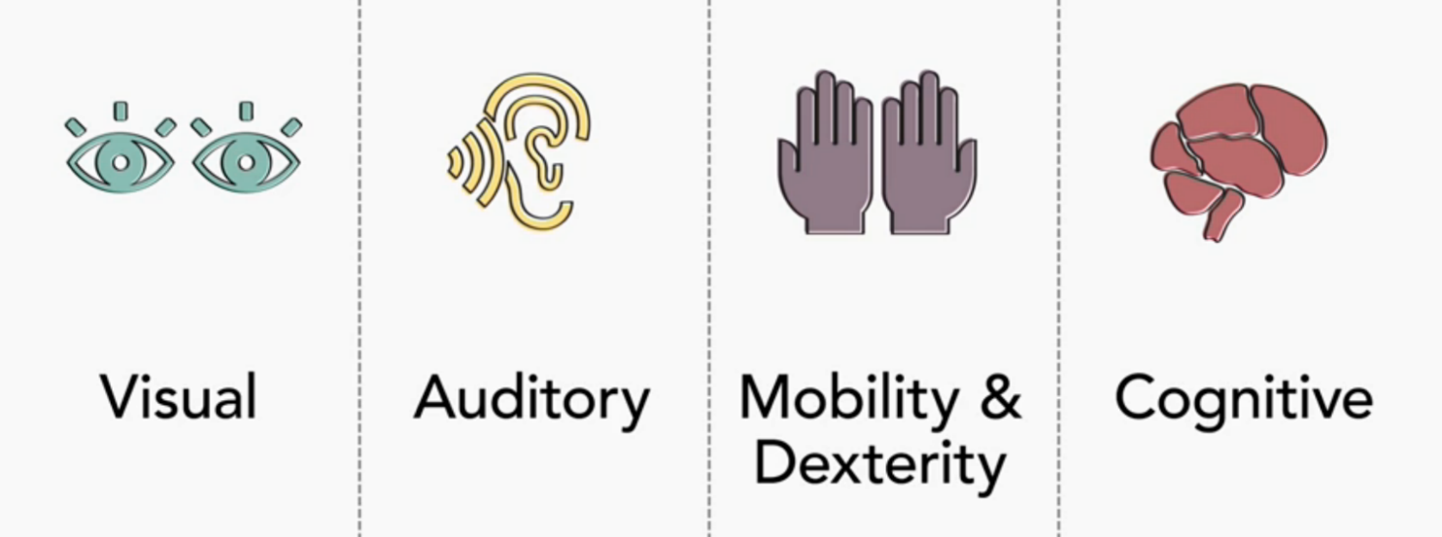

We often consider disabilities as in Physical form only; however, a large number of people suffer from mental and cognitive limitations. Such as limited skills related to planning, decision-making, and coping.

Improving your product’s accessibility can enhance the usability for all users, including those with low vision, blindness, hearing impairments, cognitive impairments, motor impairments, or situational disabilities, such as a broken arm. (Source: [IxDF](https://www.interaction-design.org/)) ( <https://www.interaction-design.org/> )

You can read more about disabilities at the [Federal Disability Reference Guide](https://www.canada.ca/en/employment-social-development/programs/disability/arc/reference-guide.html) ( <https://www.canada.ca/en/employment-social-development/programs/disability/arc/reference-guide.html> ) and an overview of key provisions of the Accessible Canada Act at [Accessible Canada Act](https://www.canada.ca/en/employment-social-development/programs/accessible-people-disabilities/act-summary.html) *(optional) (*[*https://www.canada.ca/en/employment-social-development/programs/accessible-people-disabilities/act-summary.html*](https://www.canada.ca/en/employment-social-development/programs/accessible-people-disabilities/act-summary.html) *)*

***The first and foremost step in building an accessible product is to build empathy and install an inclusive design mentality. (Source: [UXCollective](https://uxdesign.cc/accessibility-guidelines-for-a-ux-designer-c3ba775539be) )***

**Some good practices:**

* **We need strong empathy towards all users of the interfaces.**
* **When it comes to accessibility features, as designers, we need to ensure we educate our clients on what it means to be accessible and to work as partners with them towards that goal.**
* **Despite all the legislation and technical documentation urging for a more accessible Internet, the bottom line is it's just the right thing to do.**

**How to implement Accessibility?**

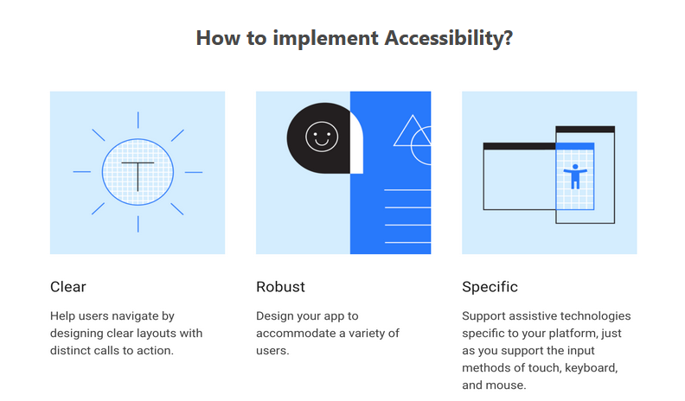

*(Image source:*[*Material.io*](https://material.io/design/usability/accessibility.html#understanding-accessibility)*) (*[*https://material.io/design/usability/accessibility.html*](https://material.io/design/usability/accessibility.html) *)*

**Implement accessibility through:**

**Assistive technologies:**

Assistive technology helps increase, maintain, or improve the functional capabilities of individuals with disabilities, through devices like screen readers, magnification tools, and hearing aids.

* **Web Content Accessibility Guidelines - WCAG:**

The [WCAG](https://www.w3.org/WAI/standards-guidelines/wcag/) (<https://www.w3.org/WAI/standards-guidelines/wcag/> )documents explain how to make web content more accessible to people with disabilities. Web “content” generally refers to the information in a web page or web application, including:

* + natural information such as text, images, and sounds
  + code or markup that defines the structure, presentation, etc.

**For example, Importance of colour contrast**

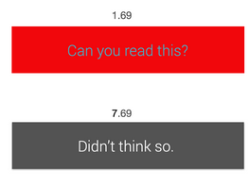

Colour contrast is important for users to distinguish various text and non-text elements. Higher contrast makes the imagery easier to see. A low-contrast image may be hard for some users to differentiate in bright or low light conditions, such as on a very sunny day or at night. (Source: [UX Movement](https://uxmovement.com/buttons/the-myths-of-color-contrast-accessibility/)) (<https://uxmovement.com/buttons/the-myths-of-color-contrast-accessibility/> )

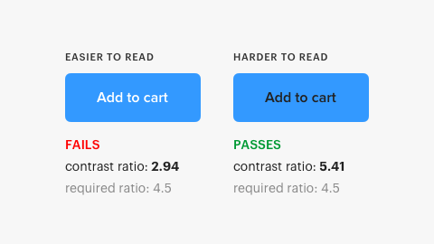

(image source: [UX Movement](https://uxmovement.com/buttons/the-myths-of-color-contrast-accessibility/)) (<https://uxmovement.com/buttons/the-myths-of-color-contrast-accessibility/> )

Try to use an indicator other than colours such as text labels or patterns. When showing errors on the screen, don’t rely on coloured text alone, add an icon or include a title to the message. Consider adding a visual cue such as font-weight or underline text style to linked text in a paragraph, so the links stand out. Elements with more complex information like charts and graphs can be especially hard to read when you only use colour to distinguish the data. Use other visual aspects to communicate information like shape, labels, and size. (source: [UX Movement](https://uxmovement.com/buttons/the-myths-of-color-contrast-accessibility/)) (<https://uxmovement.com/buttons/the-myths-of-color-contrast-accessibility/> )

* **Naitve Operating System:**

The Operating System of devices provides many accessibility options; incorporate them in your design. You can always educate your client/users for their application while accessing your website. There are some keyboarding options as well.

**Some Resources:**

[**http://www.zeldman.com/**](http://www.zeldman.com/)

[**http://alistapart.com/topic/accessibility**](http://alistapart.com/topic/accessibility)

**Accessibility for code:** [**https://www.utexas.edu/learn/accessibility/samplehtml.html**](https://alistapart.com/blog/topic/accessibility/)

**Colour contrast rating:** [**http://contrastchecker.com/**](http://contrastchecker.com/) **.**

[**Google’s Accessibility for Teams**](https://developers.google.com/web/fundamentals/accessibility/a11y-for-teams) **(** [**https://knowbility.org/blog/2018/WCAG21-intro/**](https://knowbility.org/blog/2018/WCAG21-intro/) **)**

[**A11Y Project: Web accessibility checklist**](https://a11yproject.com/checklist) **(**[**https://www.a11yproject.com/checklist/**](https://www.a11yproject.com/checklist/) **)**

[**Blog: Welcome, WCAG 2.1!**](https://knowbility.org/blog/2018/WCAG21-intro/) **(** [**https://web.dev/a11y-for-teams/**](https://web.dev/a11y-for-teams/) **)**

**Designing for Web Accessibility:** [**https://www.w3.org/WAI/tips/designing/**](https://www.w3.org/WAI/tips/designing/)

**Accessibility:** [**https://material.io/design/usability/accessibility.html**](https://material.io/design/usability/accessibility.html)